This document serves as proof that I, along with my team TEKTON,' comprising six members, am actively participating in the NASA Space Apps Challenge Hackathon. Attached are screenshots that include the official program details and our team's registration for the event. Our team, TEKTON,' is fully engaged in this competition, working collaboratively to contribute our innovative solutions. This participation requires my full attention, which is why I am unable to attend my ICT classes during this period.

This is the brochure for the NASA SPACE APPS CHALLENGE

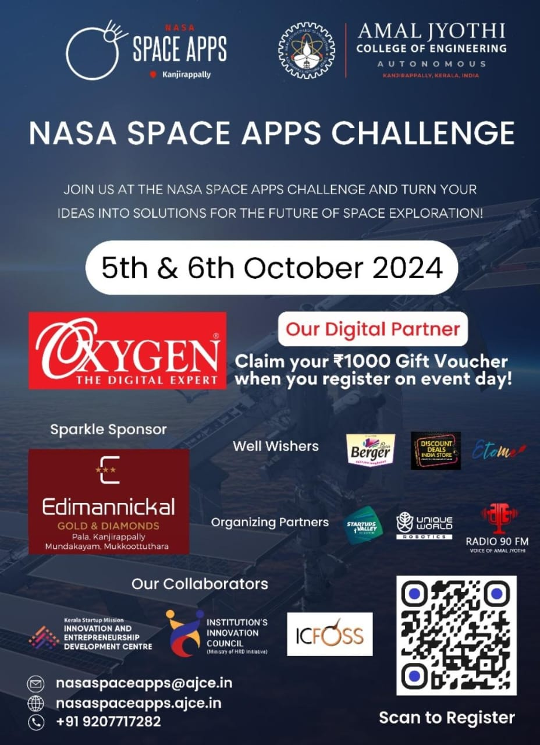

This is my team registered in NASA SPACE APPS CHALLENGE

Details of the team can be accessed through this llink :

[NASA Space Apps Challenge](https://www.spaceappschallenge.org/nasa-space-apps-2024/find-a-team/tekton/)

